

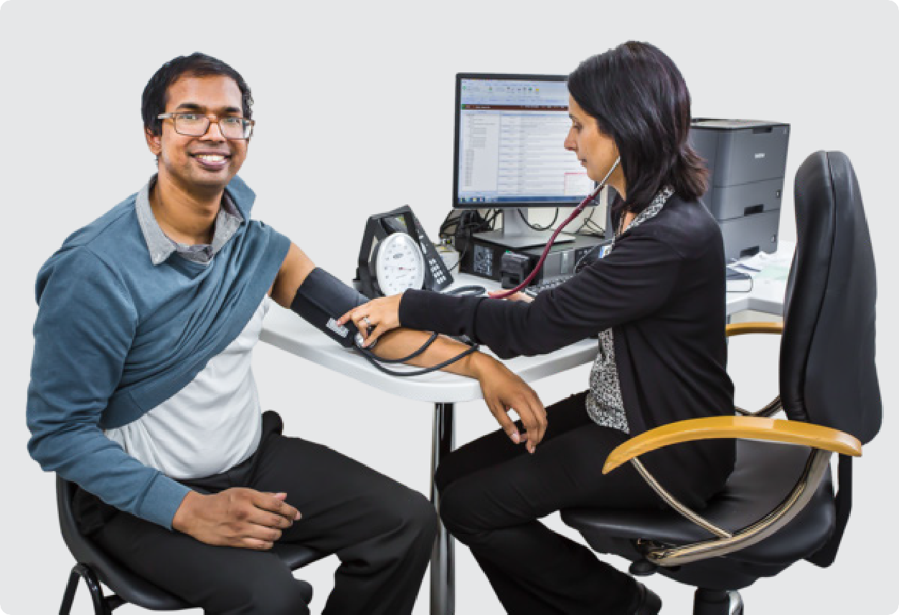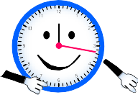

Social Story

Going for my Yearly Health Check

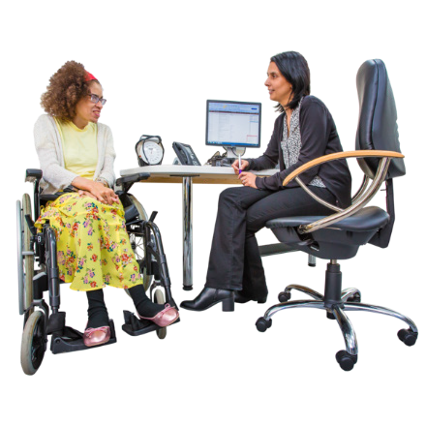I visit my GP for a yearly health check every year.

GPs and clinics call this an **Annual Health Assessment.**

At my yearly health check the GP checks my body to make sure I am staying healthy.

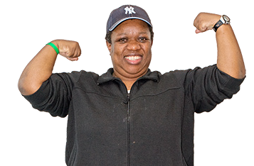

My GP’s name is

**PHOTO OF GP**

I go to

The GP’s phone number is

**PHOTO OF GP CLINIC**

**PHOTO**

Other people who might help the GP do my yearly health check are

**PHOTO**

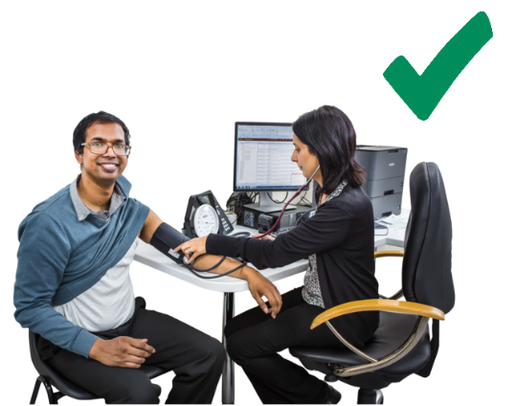

It is important for me have a yearly health check so I can

* talk to my GP about any health worries I have
* get ideas about how to be more healthy
* get help from the GP if anything is wrong with my health.

# Getting ready for my yearly health check

I ask my support person to come with me to my yearly health check.

**PHOTO OF SUPPORT PERSON**

This could be

* + A family member
  + A friend
  + One of my support workers.

My support person is

Their phone number is

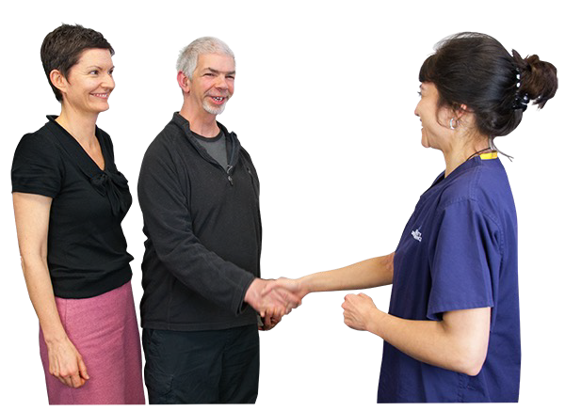

It is helpful for my support person to come along to my yearly health check so they can

* Explain anything I do not understand
* Help me speak up for my rights at my GP appointment.

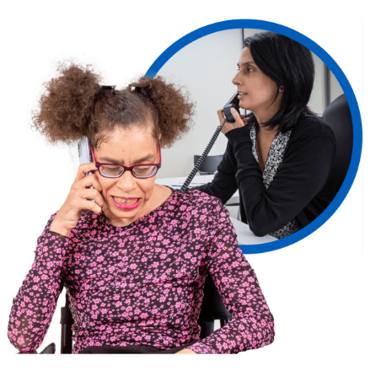I or my support person call up the GP’s office a few weeks ahead of time to book my yearly health check.

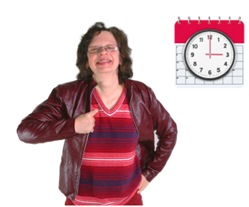This is so I can get my health check done on a day and time that suits me and my support person.

I or my support person tell the receptionist to book a long appointment.

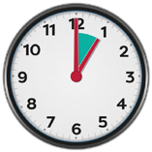

This is because my GP needs between 40 minutes and 1 hour to do my yearly health check

My appointment is on

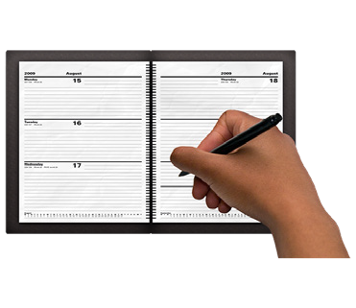at

I write my appointment day and time on my calendar so I do not forget.

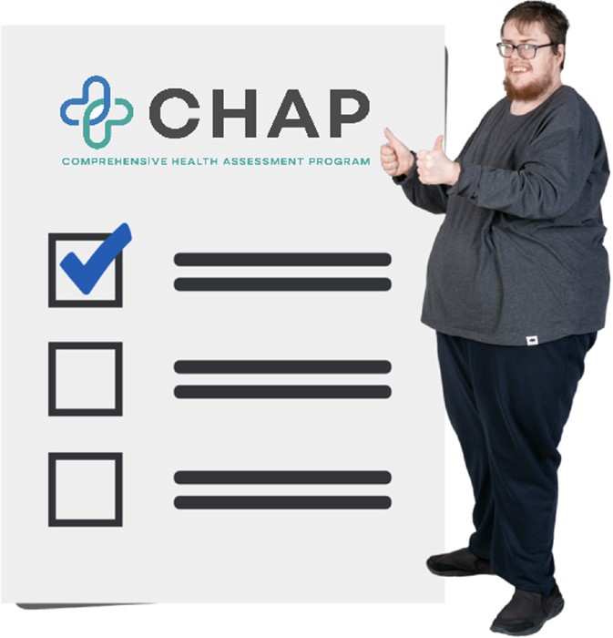

My GP may use the **CHAP form** to do my yearly health check.

CHAP stands for the Comprehensive Health Assessment Program.

The CHAP form helps my GP to get important information about my health.

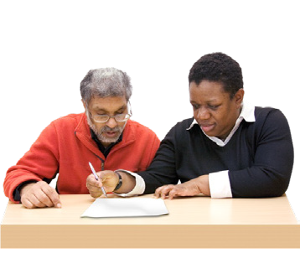The CHAP form has 2 parts.

I need to fill in Part 1 of the CHAP form before my yearly health check appointment.

I can ask my support person for help to fill it in.

Part 2 of the form is for my GP to fill in at my appointment.



I make sure to take Part 1 of the CHAP form with me to my yearly health check and give it to my GP.

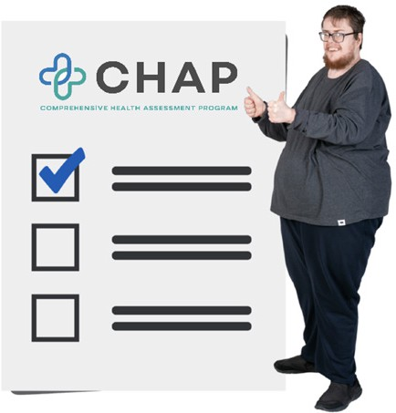

For more information on how to fill in Part 1 of the CHAP form [click here.](https://www.health.gov.au/resources/collections/comprehensive-health-assessment-program-chap-annual-health-assessment-for-people-with-intellectual-disability)

# On the day of my yearly health check

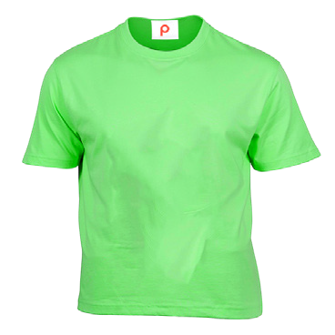I make sure to wear a short sleeve top on the day of my yearly health check.

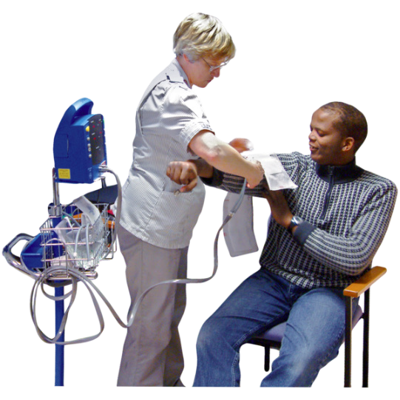This makes it easier for the GP or nurse to check my blood pressure.

**PHOTO OF CLINIC WAITING ROOM**

When I get to the GP clinic I let the receptionist know I am there.

Sometimes I must wait for a while.

I may be able to wait outside or in the car. The GP will call my name when it is my turn.

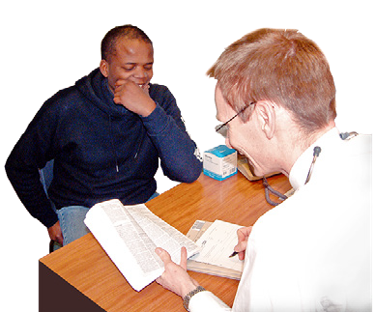I give my GP Part 1 of the CHAP form that I filled in before my appointment.

They will spend a few minutes reading through it.

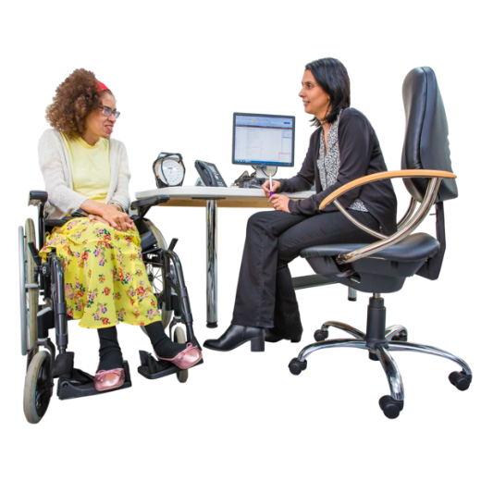The GP will ask me a lot of questions about my health.

It is okay if I do not know all the answers.

I can say no if there is a part of the health check I do not want to do.

During my health check the GP or nurse may check things like:

* My eyes and ears

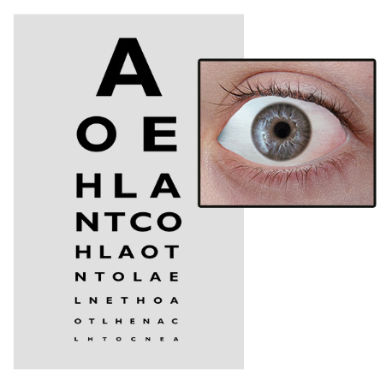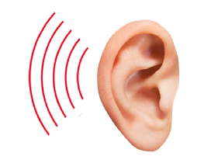

* My heart and my breathing
* 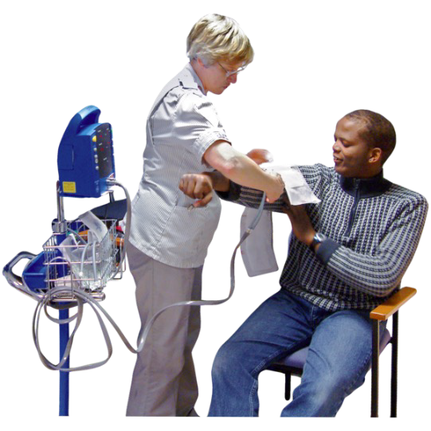My blood pressure.

The GP will talk to me about my eating and exercise.



They will also ask about any medications I take.

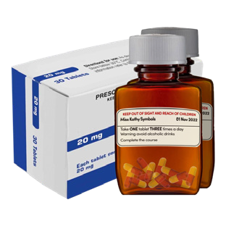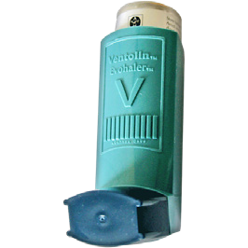

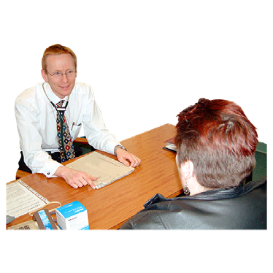After my health check the GP will talk to me about how it went.

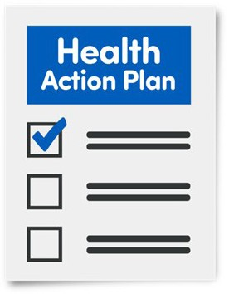My GP makes me a **Health Action Plan.**

A Health Action Plan tells me what I need to do for my health.

It says what my GP will do for my health too.

I take home a copy of my Health Action Plan.

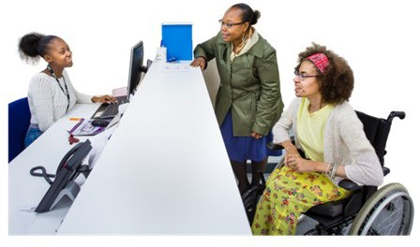I might need to make another appointment to get any test results back.

I can also book in my health check for next year if I want.

I can do this with the receptionist before I leave the GP clinic.